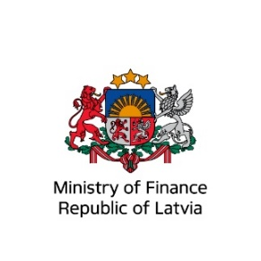

International Financial Institutions’ Financing and Risk-Sharing Solutions in Ukraine’s reconstruction
8 February 2023 | Ministry of Finance Latvia
Ukraine’s post-war recovery and reconstruction needs will be extremely high – estimated at about USD 349 billion, to restore public services, repair damaged infrastructure, and sustain the economic activity. This will include investments in agribusiness, manufacturing, infrastructure, and many other areas. Private sector export-oriented companies across the world, including Latvia, can support Ukraine’s reconstruction efforts by implementing projects financed and procured by the IFIs, benefiting from a variety of financial and risk-sharing instruments.
The main objective of this workshop is to introduce the Latvian private sector with the IFI’s – IBRD, IFC, MIGA, EBRD, EIB, NIB, CEB operations and upcoming reconstruction project pipeline in Ukraine, and present IFI’s financial and risk-sharing instruments in Ukraine and other developing countries. The workshop will also present an opportunity to deepen knowledge on practical engagement in IFIs project procurement and implementation, sharing best practices and respond to individual questions of participants. The workshop is hosted by the Latvian Ministry of Finance in cooperation with the Ministry of Foreign Affairs, Latvian Chamber of Commerce and Industry (LTRK), Investment and Development Agency of Latvia (LIAA), Employers’ Confederation of Latvia (LDDK), American Chamber of Commerce Latvia (AmCham Latvia).

14:30-15:00 | Registration & coffee
15:00-15:10 | Welcome address  Mr Arvils Ašeradens, Minister of Finance, Governor of the IFIs
15:10-15:20 | International Bank for Reconstruction and Development (IBRD)  [Presenter TBC]
15:25-15:35 | International Finance Corporation (IFC)  Ms Elena Voloshina, Country Officer for Ukraine
15:40 -15:50 | Multilateral Investment Guarantee Agency (MIGA)  Ms Annabelle Libeau, Investment Guarantee Officer
15:55-16:05 | European Bank for Reconstruction and Development (EBRD)  [Presenter TBC]
16:10-16:20 | European Investment Bank (EIB)  Mr Jean-Erik De Zagon, Head of the EIB Resident Representation in Ukraine
16:25-16:35 | Nordic Investment Bank (NIB)  Mr Vilius Girkontas, Senior banker, Country Lead for Lithuania and Latvia
16:40-16:50 | Council of Europe Bank (CEB)  Ms Jasmina Glisovic, Principal Country Manager
16:55-17:00 | Closing remarks  Ms Inga Forda, Ministry of Finance Latvia
17:00-17:30 | Coffee & networking

